CURRICULUM VITAE

DAVENDRA SINGH RAWAT Mobile No:- 9718052756

Professional Qualifications:
- Diploma in Civil Engineering from Jamia Millia Islamia University, New Delhi in year 2007
- Civil Draughtsmanship from Govt. Industrial Training Institute (ITI) in year 2001 form Delhi.
- Three months Computer Course in Auto-CAD form DG-TECH Computer Institute, Delhi

Academic Qualifications:
- Pass Secondary Board Examination, Delhi in year 1996
- Pass Senior Secondary Board Examination, Delhi in year 1998
- Bachelor Degree in Computer Application (B.C.A.) From I.G.N.O.U., Delhi in year 2004

Industrial Training:

Public Work Department (P.W.D.), Sub Division -21, Delhi | One year Industrial Training  Training Area: Abstract to Cost & History Sheet & drawings for Road Survey.  From Dec-2002 to Dec-2003

Work Experience:

- Organisation : M/s JAIPRAKASH ASSOCIATES LTD.
Noida-128, U.P.
Designation : Sr. Field Engineer (CAD) - Structure
Duration : Feb2008 to Till Date
CAD Technologies : AutoCAD
Job Description : Preparing Structural Drawings
& Site Coordination

Personal Details:

Date of Birth : 18/01/1981
Material Status : Married
Address : H.No. C-18, Upper Second Floor, Gali No.-3 Kotla Village, Mayur Vihar Phase-1,
Delhi-110091
Permanent Address : Village & Post office Dulhi, Via
Laxman Jhula, Distt.-Puri Garhwal (UA)
Mobile No : 9718052756
E-mail Id : dav2011rawat95@gmail.com
Hobbies : Surfing Internet, Reading Books and Playing
Volleyball

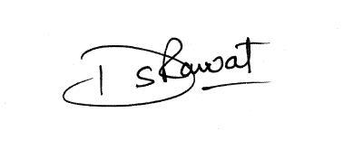
[DAVENDRA SINGH RAWAT]

